Session report n°2 (22/10/2022)

SATRAGNO Anthony

**Session’s Subject:** Mechanical displacment

**Goal :** Researched more precisely the components to order (Chain, possible bearings, etc.), then focus on the reduction/Transmission systemI/ Composants et commandes

1. Tracks

We have observed that the length of tracks necessary to make a robot of length = 30/40cm would be between 90 and 120 cm. We therefore directed our research towards pool robot tracks, made of rubber or silicone and already adapted to the salty aquatic environment (psiicne treated with salt).

Several models have been selected: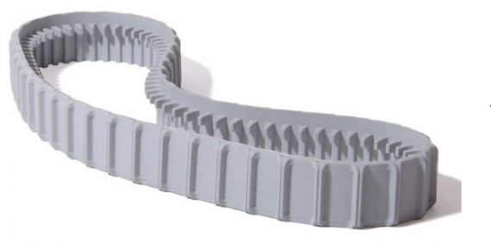

Gray caterpillar for Poolstyle/Poolstyle Plus/Serie Z pool robots

Ref: MAY-201-1300.9983152

Track for Tiger Shark robot

Ref : RCX23002

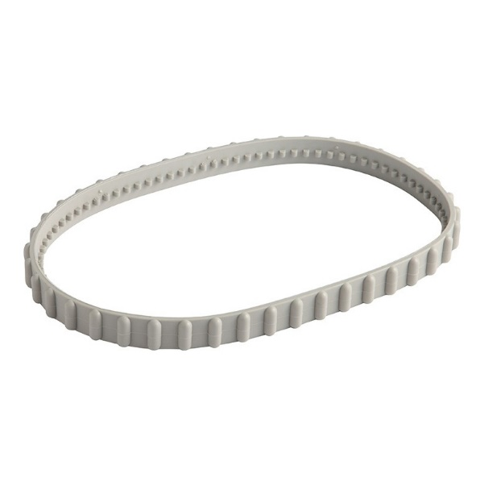

And the size of each component of the drive system of these tracks will be decided when we receive the first track. If it turns out to be too big or too wide, we can order the second one or opt for a 3D printing of a custom track.

1. Motor

In the middle of the session, the supervising professor asked us to look for an engine on a site other than Alibaba. Unfortunately, after two hours of research we concluded that the best option was to order the motor in question (24V) on Alibaba.com, and in the event of a problem with the delivery or the operation of the motor, we will consider using non-resistant motors to water, then much easier to order and to choose, but involving the design of a suitable waterproof box allowing the motor shafts to pass.

The motor in question requires a 24V power supply and that of the propeller 12V, we have also included the use of a voltage converter to be able to adapt it to each motor.

## II/ Transmission/Redcuction System

1. Theory

I studied for 1h30 the operation of gears, reduction systems and the mathematical formulas behind. This site summarizes everything there is to know on the subject:

<https://windowstechies.com/-/fr/filename-msa/?file=calcul%20engrenage&msclkid=f397c9fe7f4711eb798daaaa7f81539d&utm_source=bing&utm_medium=cpc&utm_campaign=FR%20%2F%202013%20General%20(ASR)&utm_term=calcul%20engrenage&utm_content=Rush_June12_28>

1. Pratique

In practice, when we have received the chain, it will be necessary to measure its exact perimeter and its number of notches, deduce the perimeters of the sprocket, the bearings and the lower rollers as well as their number of teeth. Then it will be necessary to define the desired speed of the robot in m/s, and to calculate at what speed in rpm we want our sprocket to turn.

This will allow us to define the desired ratios between each branch between the motor and the gears.

It will also be necessary to define the speed in rpm of the robot brushes and the squeegee actuation system.

In summary :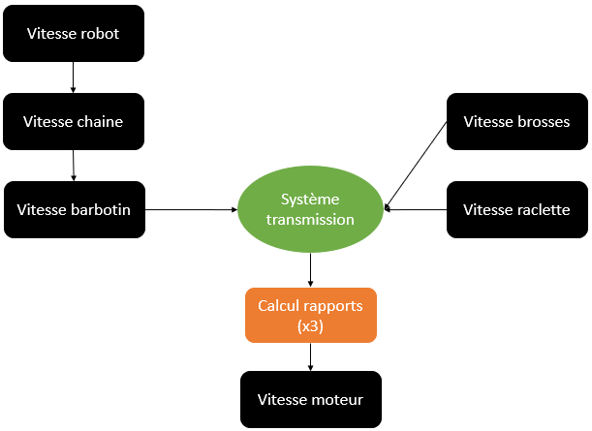

**Conclusion of the session:**

We were unfortunately delayed by this engine incident, but now the choice is clearer and we have a ready solution for every situation. It seems obvious that the calculation of the chain of gears and the ratio between each will certainly take time and it will be necessary to carry them out as soon as possible, outside of class, in order to be able to launch production as quickly as possible and carry out tests.